Wasting time talking nuclear
David Leitch
2024-12-27

Summary - Australia’s economic future will be at risk if we stop the wind and solar construction to build nuclear
Building a nuclear industry in Australia:
- Makes blackouts more likely by forcing coal stations, already expensive to maintain, that require Govt support and are increasingly unreliable to go for much longer. The idea of replacing the coal plants with gas while we wait is likely not very realistic, largely because gas plants themselves are expensive and hard to permit and because if asked to run in shoulder mode they are not very efficient and require lots of gas. And right now we are already looking at importing LNG.
- If the nuclear plants are 5,10 or 15 years late as is entirely possible it would require heroic assumptions to see the coal fleet managing the gap. More to the point its a completely avoidable and unnecessary risk. Australia is well set on its transition path. There are some inevitable cost up and downs but no show stoppers have been identified. Every hurdle from reliability to inertia has been overcome. There is no need and no reason to change course. Certainly economics is not a reason.
- Increases emission costs by between A$57 and A$72 bn (NPV @ 7%) even in the very unlikely event the plants are built on time as compared to the present ISP
- The nuclear plants stand a good chance of being well over budget and late. That’s because:
  - Globally that is often but not always the case. By and large the nuclear industry is one of the most likely global industries to be late and over budget.
  - There is no real nuclear expertise in Australia;
  - It will have to be more or less forced on an industry set on a different course;
  - It will likely be Goverment owned and developed and the record on that in Australia is poor;
  - In general for most capital intensive industries there is an Australia cost premium relative to global averages. This in the end will disadvantage us compared to other countries in terms of the cost of energy.
- Likely will destroy the value of CER in Australia.
- Will result in the temporary halt in the transition to a firmed VRE system which is already 20 years down the track with a penetration rate of say 50% within 18 months.
- Equally the LNP and by comparison Frontier don’t appear to have done the work or to understand the demand forecasts. The LNP bleat on about EVs but the real differences are hydrogen, large industrial loads and business demand. One suspects that the aluminium industry in Australia will die if it has to wait for nuclear.
- Finally the old concept of baseload is changing but in my opinion firming costs are cheaper the bigger the portfolio. This implys firming should sit at least with a large gentailer or possibly with a State or even Federal Govt.

The existing wind and solar build out is working, and its far too risky to rely on old coal plants
The biggest, by far, reason for the electricity industry to push back against the ideological LNP Nuclear plan is its far, far too risky.
Australia has a plan to decarbonise. It’s not a perfect plan, no plan survives first contact, but it’s capable of and is in fact being achieved. We are roughly already at 40% VRE. We have at least 20 years experience at developing and integrating wind, solar, behind the meter assets and batteries.
We know the issues around transmission and social license and cost and reliability. There are well developed plans for each issue and a wealth of industry finance and expertise.
The assets to take us from 40% VRE to 50% are already under construction, some are just starting to enter service.
The insurance finance to add another 12 GW of VRE and 4 GW of firming assets (essentially batteries) is already either awarded or in tender through the CIS.
The LNP wants to bring this to a crashing halt, keep our few, increasingly ageing and unreliable coal stations going for another 20 years while it starts up an industry in which Australia has zero comparative advantage and zero experience. Only in politics could conmen say things with such a straight face. The risk of the coal stations failing is very high. Other stations like Eraring have full ash dams. Yallourn is already on Govt support, Vales Point and particularly Mt Piper have coal supply issues.
Gladstone Power Station in QLD is ready to close. And so on.
It simply isn’t prudent for Australia to depend on these stations as a group to do another 20 years. It’s a completely unacceptable risk that politicians want to expose Australians to, purely for the sake of politics. I could but wont go into the politics. It is quite sufficient to point out the risk, and really I could close this note at this point completely confident that the argument is made.
The LNP might argue that they would build more gas stations. To start with they take time and planning and secondly where is the gas? Where ever it comes from it will be expensive. I’m just not going there. By all means build a peaker or two but its a sideshow to the main game which is bulk energy and shifting it through time and space.
For what it’s worth the following figure shows the closing of the Crocodile jaws. The top jaw is coal and gas generation and the bottom jaw is wind, solar and hydro. The jaws didn’t close much this year, due to wind drought and some utility solar price constrained off but they surely will next year as about 2.5 GW of wind currently in commissioning gets to full production and some more solar farms as well. In addition there is 6 GW, count them, 6 GW of batteries under construction. Using a 180 moving average allows the informed view to see the Winter v Spring Summer impact.
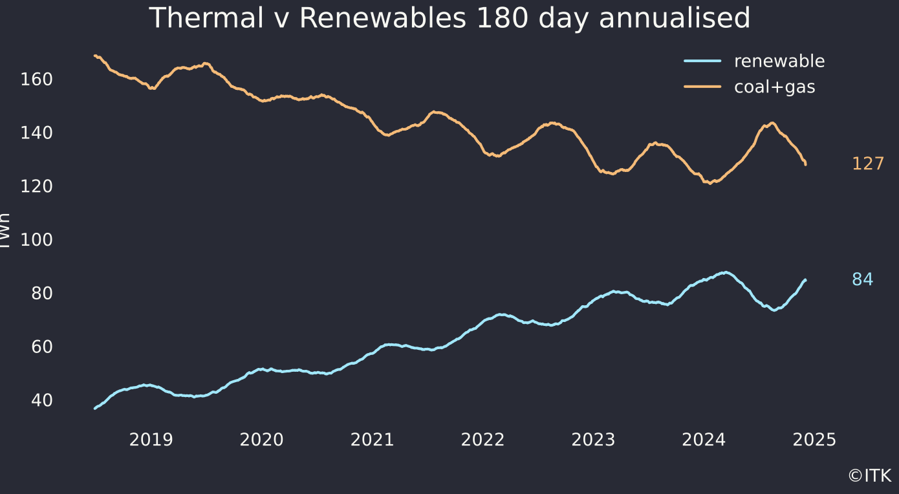
Figure 1: Thermal v Renewable Australia. Data source:NEM REview

The errors and sleights of hand in Frontier’s nuclear v ISP analysis
Like many another analyst I’m prepared to look at any technology on its merits. However biased reports, in particular reports that are so biased as to be almost political advertisements are unlikely to serve any better purpose than politics. If Frontier and its front man Danny Price wanted simply to write an advertisement for the LNP and endorse their policy then why not say so? If Frontier on the other had any interest at all in bringing the industry to their point of view then the report is an abysmal failure. Its failings are so obvious that it hardly needs me to do a me to, but I have.
As I’ve stated before a presumption of bias can be attached to the report with 100% confidence for three reasons.
- Firstly the use of “real costs” rather than NPV. As previously stated this simply does not meet a professional standard.
- Secondly the headline comparison between the ISP step change costs and the Progressive Change costs using nuclear. I mean give me a break, comparing two different scope projects on the basis of cost? This frankly already means that any pro will ultimately consign the report to the garbage tin. Such a comparison belongs in the world of political theatre not in the industry court room full of expertise and professionalism. Quite frankly I expected more from Frontier than such an amateur show of gross political bias. Frontier’s record was strong.
- Thirdly Frontier does not account for the cost of carbon emissions. If the cost of emissions was the same for both the ISP and the nuclear approach then it would make no difference. But the emissions are in fact different and it is, in my opinion a very poor effort by Frontier not to allow for the cost difference. It’s yet another example of the bias in the report and Frontier’s cavalier indifference to decarbonisation. The higher carbon emissions mostly incurred from about 2027 to 2040 and so whatever price is used for the emissions the NPV will likely be significant.
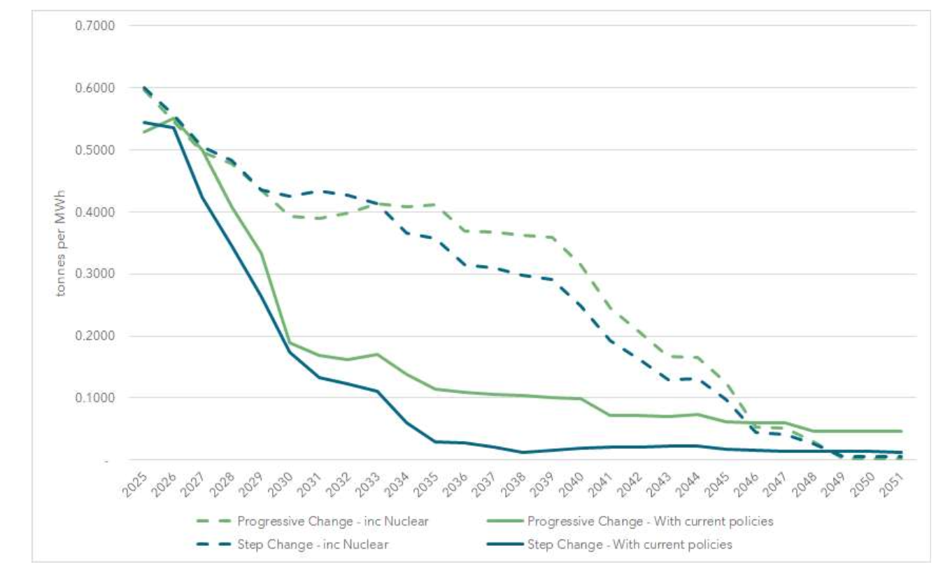
Figure 2: Emissions intensity (t/MWh. Source:Frontier)
​ There are lots of estimates of the cost of carbon. These range from the Gillard Govt’s cost which the LNP revoked adjusted to $ of today which Frontier states would be about $40/t, through to the European price presently around Euro 68 = $A113/t, through to a major, multi author estimate published in Nature with a mean of $US185/t = $A 296/t (but the range is US$ 44 to $US 413/t) to the USA official estimate of $US 51 =81.54 AUD $A 81/t through to the AER estimate of $A 75/t in 2025 rising to $221 by 2040. And finally there is the set of numbers adopted by the AER which rise strongly over time and which I have used
Frontier could have used any of these numbers but they don’t. The extra carbon emissions are not regarded as a cost worth considering in Frontier’s numbers! On my numbers the NPV of the increased emissions is between $57 bn and $72bn
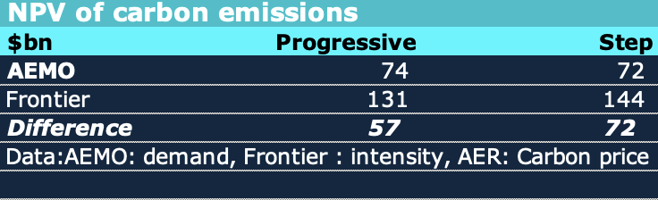
Figure 3: NPV carbon emissions. Source: ITK bssed on Frontier figure
The method for calculating this was:
- Get ISP total demand by year in TWh for Progressive and Central(Step change) cases.
- Estimate emissions intensity year by year from figure presented by Frontier Economics
- Calculate total sector emissions for each year (demand * intensity)
- Calculate gross annual cost using AER Carbon price, being the Australian reference point.
- Calculate total NPV of annual costs using Frontier Economics 7% discount rate.
I might add that the social cost of carbon is normally calculated with discount rates of 2%-4% given that the damage is long lasting but I haven’t considered the methodological issues around that here.
The overall point remains that there can be no excuse whatsoever for Frontier ignoring the cost difference. Frontier could have used some other carbon price estimate, but there is no doubt that carbon emissions have a cost, that is why we decarbonising and not considering that cost renders the Frontier exercise fairly useless.
In an AFR article Prices states that the AER carbon cost does not represent the “economic cost” without producing a shred of evidence to support this view. And in fact the comment seems to me to be revealing of the underlying philosophy of Frontier that global warming is over stated as an issue.

Confusing costs and NPV
Some of the justified criticism of Frontier is in the way it adds up “real costs”. For instance:
- Frontier annualise capex in reporting generation costs, as does AEMO in the ISP results. This is done by essentially converting the capital cost to an annual lease payment whose present value over plant lifetime, at the chosen WACC, is equal to the actual capex.
- But Frontier then add these annualised amounts up with no discounting and claim the totals are ‘economic costs’:. Given the annualization of capex, the only way to represent its true economic (resource) cost is to take the NPV at the same WACC used for the annualization. .
However since the use of “real costs” for investment analysis is in any event fatally flawed from the outset and contrary to the laws of Finance, and because I think Danny Price knows that perfectly well I tend not to worry about methodological flaws of “real costs”.
Equally Steve Hamilton in his excellent AFR piece noted that AEMO incurs its capital costs from today onwards but the the nuclear costs are only start to be incurred from 2035. In NPV terms costs that are incurred later have a lower NPV than costs that incurred earlier Steve noted that if we just compared costs in 2050 there is only a 12% difference between the nuclear and AEMO difference.
However in NPV terms, if we allow for the difference in carbon costs, these differences matter less. In effect Frontier defers capital spending improving NPV but incurs carbon costs which reduce NPV. Its just that Frontier doesn’t count the carbon cost.
Also once the capital spending on VRE has been made the annual operating costs fall sharply compared to existing coal. Wind opex for instance is around A$10/MWh compared to say A$50/MWh for existing black coal, maybe less for brown coal. However in my opinion its unlikely that AEMO captures all the maintenance capital expenditure required on end of life coal assets that are not just end of life but also have to be ever more flexible, ever more capable of ramping. So I personally think but wont take the time to illustrate this issue but just look at the costs being incurred by AGL, the Govt support offered to Yallourn and Eraring.

Frontier’s Nuclear costs
Frontier estimates a nuclear cost today in Australia of A$10,000/Kw which then falls by 1% per year from today. So the A$10,000 is effectively a misleading number. In that Frontier’s estimate of cost is actually in real terms as Hamilton calculates about A$8,500/KW in 2040 and continues to fall.
I don’t have any problem with learning rates in an industry, solar, wind, batteries and many, many other technologies have a learning rate, representing the reduction in unit costs for a doubling of installed capacity.
But I think any reasonable person would question whether it’s appropriate to apply a learning rate to an industry that hasn’t even started in Australia and where the year 0 number is still very much in question. And, to the best of my knowledge, there hasn’t been much of a global learning rate in nuclear, although there may be one in China. In fact academic articles suggest that the experience curve for nuclear depends on the time and country.
One oft cited reference is “How Big Things Get Done” by Betty Flyvbjerg and Dan Gardner, 2023. A key figure from that book is:
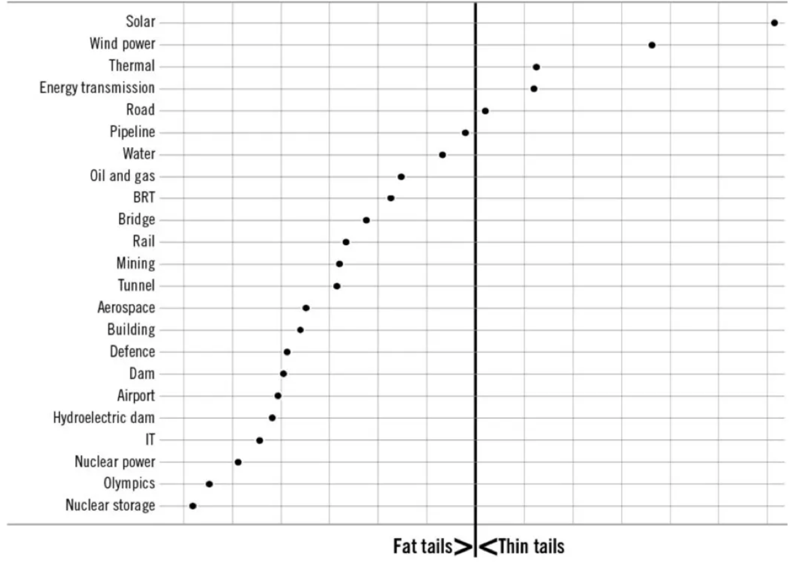
Figure 4: Cost and time performance Infrastructure. Top right quadrant is where you want to be
The horizontal axis represents on time, expectations, further to the right is more on time, the vertical axis shows on budget. industries in the bottom left quadrant tend to have “fat tails” which means that the outcomes vary. Perhaps in China nuclear goes well, but in the UK or the USA it goes badly. On average it goes badly. Solar and wind go well.
The figure is based, I believe on data summarised in the following table. The fact that olympics and nuclear have cost over runs most of the time surely cannot be a surprise to anyone.
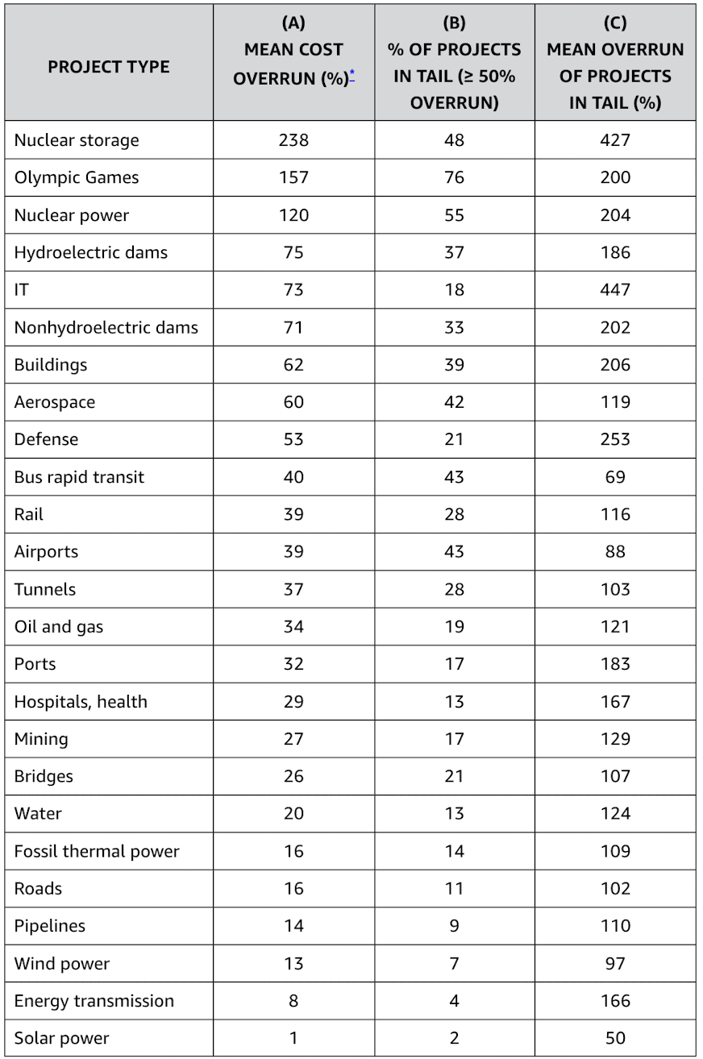
Figure 5: Projects by chance of cost overrun. Source: Flybjerg and Gardiner
To me this is so intuitively obvious as to not need stating. Wind and solar projects take a couple of years to build, the technologies are modular, capable of being repeated and relatively small scale. Even a 1 GW wind farm represents 150 concrete pouring, each more or less the same, 150 turbines erected each the same way and so on. And Australia has done 1000s of turbines already.
By contrast Lucas Heights notwithstanding Australia has absolutely zero nuclear experience or expertise, nuclear plants require much more planning, contracts that inevitably will need to be renegotiated and so on. The mind truly boggles. And in the end we would have zero comparative advantage. Whatever Australia’s nuclear cost it wont be lower than anyone else’s. How could it be?

Are coal miners likely to be able to retrain for nuclear?
Modern nuclear plants with higher levels of automation might employ 500-800 people. According to a rough industry source about 50% -70% of those jobs will be in operations, maintenance and technical support. Roughly 25%-50% of the people will be engineers of one kind of another.
Uranium mining and processing is not going to be taking place where nuclear plants are located. The idea that coal miners will down tools and suddenly start working in a nuclear plant is something only an LNP ideologue could truly believe.
Of course like any business there will be second order GDP multiplier effects.
However I think its reasonable to assume that both the primary and secondary GDP impacts of building out regional REZs will be higher per $ of capital expenditure because by and large they come off a lower base. Building out the ORANA REZ will have major impacts, not all good, and not all sustainable on the regional economy. But for ever after the regional economy will have a more diversified industry base that, in my opinion, will enable it to better withstand the vicissitudes of the Australian climate and its ever more extreme drought and flood cycles.

Govt funded and managed likely increases risks very significantly
As far as I know the electricity industry in Australia has expressed zero interest in nuclear and obviously some parts of the industry that are busy building wind and solar will be actively opposed. Clearly this in itself is likely to raise costs. That is the nuclear plants will have to be forced on the industry to a greater or lesser extent.
Again although the plans are very vague the understanding is that they will Goverment funded and owned. Leaving aside all questions of ideology, in my opinion having the Goverment manage the program rather than industry means that there will be less expertise at almost every stage. I could rant on about this, the mind truly does boggle a bit at the possible negative outcomes but perhaps it is sufficient to say that having the Goverment step into this area where it has no expertise raises the odds of cost and delay outcome substantially.

Demand shapes
Frontier provided no shapes to their demand or supply forecasts, just the annual totals. This has lead to questions on how 13 GW of flat supply will impact the output of other fuels. Danny Price from Frontier stated that once the 13 GW was forced in the system was “re optimised” and the capacity factors, 90% in the case of nuclear, are a model output.
And to be fair there is presently must run coal generation in the system which effectively provides a level of flat supply. That level continues to decline, and at least in Spring, the must run nature of coal already forces prices below zero and results in utility solar spillage. As to what fuel gets spilled that is a matter so far of policy and economics.
Utility solar, and wind contracts can be written so that negative prices are not covered, the CIS has such a contract. Each contract for differences may have its own wording and since I don’t see any of them I’m cautious about generalising.
AEMO provides via the ISP as Frontier does not, half hourly demand traces by region and POE (10% and 50%). ITK has spent more time than I care to admit looking at these demand traces over the past four years and puzzling over what and what not is included in say “OPSO modelling”. A good starting document is: Forecasting_methodology and for the half hourly data we want Section 6 starting at p57. AEMO is thorough with its demand forecasting, but that does not make the outcomes reliable, that’s the point really, some things are just hard to forecast no matter how thorough. Still I find its well worth reading that Section 6 several times, because as Dylan sang way back in the early 1960s “dont criticise what you cant understand”. And this stuff aint that easy to understand.
The following figure shows the shape of average daily demand in 2050 for both the Progressive and Stepchange scenarios with the horizontal red line showing average nuclear output at 90% capacity factor.
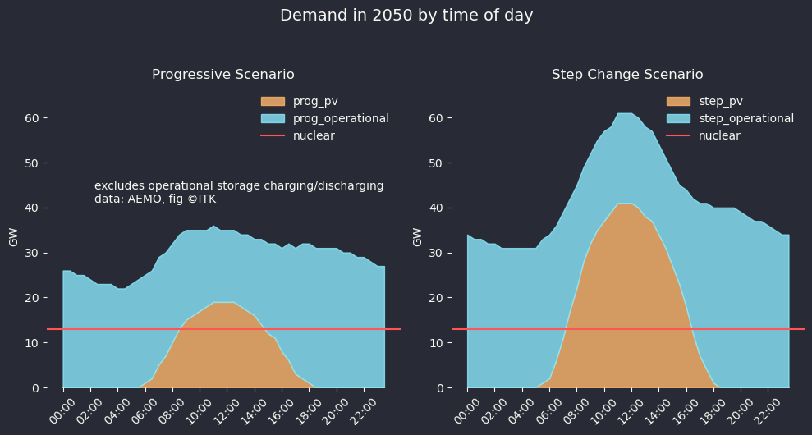
Figure 6: Demand 2050 by time of day. Data, AEMO
It’s fair to say that rooftop supply is always a bit out of place on a demand figure but that is the way its done. Operational demand is gross demand less rooftop supply.
Time of day averages are just averages. Particularly in the step change case in the ISP view of the world much of the lunch time surplus goes to charging storage to meet some elements of demand in non solar hours. The way I’ve constructed this figure in the Progressive case nuclear replaces virtually all the exiting rooftop and a significant portion of utility supply. In the Step Change scenario it’s still cutting out quite a bit. And that’s out in 2050 when in either Progressive or Step demand is a lot higher than in 2025.
It seems intuitive that if nuclear is supplying say 50% of operational demand (more in the Progressive case) that some other sources of supply are going to be running at fairly low capacity factors. However Frontier’s modelling apparently doesn’t show that..
This remains an unresolved issue. The numbers appear to show that with nuclear meeting 50% of Progressive Scenario demand in 2050 that capacity factors of other fuels will be impacted even with storage demand included. Frontier says this is not really the case and they have the gold standard PLEXOS modelling to prove it. One potential path to reconciliation would be for Frontier to show more results including those with behind the meter PV and storage and some average daily shapes, but I’m not holding my breath. Frontier did such a poor job the first time round the wise course for them would be to retire from the field and not give their many critics more oxygen.

In adopting the Progressive case the LNP implicitly calls for the end of energy intensive manufacturing in Australia
I spent time this year working with AEMO’s demand forecasts. In my view not enough attention is paid to demand as virtually all the mainstream focus is on supply and or price. But price represents the intersection between supply and demand, and the primary way to decarbonise an economy is to decarbonise electricity and then electrify other energy sources. AEMO makes the job hard because their demand portal would I suspect, confuse even Edward Teller. At the risk of a minor digression, the Progressive demand case assumes that most large industrial loads (LIL) close around 2030. That would be the Tomago and Boyne Island and Portland aluminium smelters. Is that really what the LNP wants to happen? Here are the LIL forecasts for the two scenarios and then the state by state forecast for the Progressive scenario.
Assuming, rarely a good decision, that I’ve successfully navigated AEMO’s demand portal and the recut and supposedly easier to follow analysis I show at ITK_demand_portal then I get the following main item comparison between he various demand scenarios in 2050. Note that sum EV load is cotained in the res_sum row below. Nevertheless the point remains that talking about EVs maybe good politics for the LNP, even in Ted O’Brien’s Sunshine coast electorate where there are many EVs but it doest go to the major differences in the scenarios.
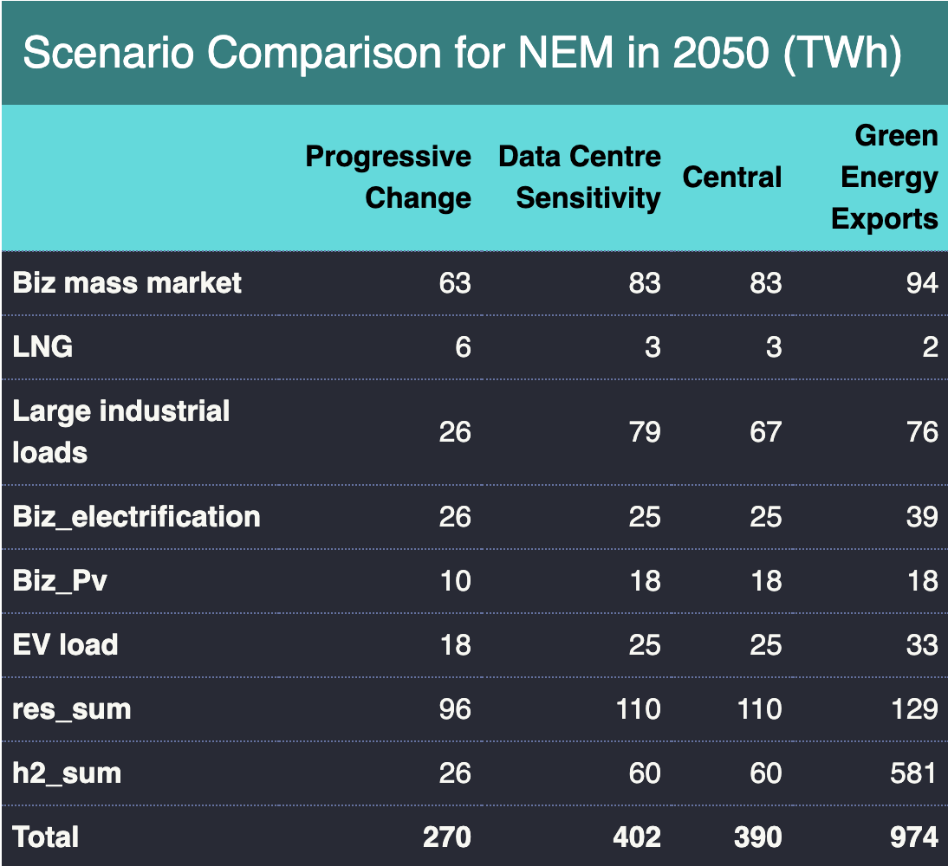
Figure 7: Demands scenarios, Source: ITK analysis
Ignoring Green Energy Exports (everyone does) you can see that in fact the main differences between Progressive Change and Central are:
- Progressive has 20 TWh less of Biz mass market;
- A major difference in Large Industrial Loads. The assumption is that in the Progressive scenario all the aluminium smelters close around 2030. No doubt that will make Frontier and the LNP happy;
- A major difference in hydrogen production and export. As I have previously written I am pessimistic about achieving the hydrogen demand forecasts of the Central (Stepchange) case. And that will have implications for supply because one can assume hydrogen supply is interruptible and this can be used to reduce the firming load. Equally around 35 TWh less wind and solar output are required with Progressive hydrogen or around 10-11 GW less wind and solar.

Base load and energy intensive business
Traditionally energy intensive businesses in Australia, primarily aluminium smelters, negotiate heavily discounted electricity prices with State Govt’s in return for investment in smelters. Traditionally there has been a role for base load in the large industrial loads sector. However, in my opinion, the way to provide the firmed power has changed and the same result can be achieved, arguably at a lower cost, especially when carbon emissions are accounted for.
As of today the State Govt contracts have often been transferred to private entities eg to AGL and other generators in Victoria in respect of the Portland smelter.
However there is no way the private sector is going to incur losses to support an aluminium smelter. The smelters remain a big industry collectively consuming around 9%-10% of electricity (the share relative to operational supply is higher).
The relevance of the term “baseload” is best understood in the context of say an aluminium smelter which in Australia typically wants a flat supply, that is a supply every half hour of about 0.9 GW. Traditionally in Australia a coal generator backed up by contracts in the market and a retailers general supply portfolio was the the way it was done.
For instance in QLD the Gladstone Power Station is 42% owned by Rio, in Victoria Portland smelter traditionally contracted with LYA, although that has now changed. In Tasmania the Bell Bay smelter, surely one of the older smelters in the world, contracted with Hydropower of Tasmania.
In each case though there is a State Govt providing a subsidy one way or another in the background.
As the coal stations go away, several questions arise, but the one of relevance here is how to provide the smelter with its flat load without a coal station.
So far the emerging answer seems to be that the smelter will provide the VRE itself but depend on the State Govt to provide the firming. For instance in February 2024 Rio announced a deal to buy 80% of the 1.4 GW Bungaban wind project and 100% of the 1.1 GW Calliope solar farm, so far Rio has not announced any firming of this energy. The output of the two projects should be around 6 TWh per year enough to power most of the smelter when generating. Clearly there will be too much generation at some points and too little at others, and the missing link is the management of the difference.
What it shows to my way of thinking is a requirement for all the parties to think beyond a simple contract for differences where by Rio buys power from the market and the QLD Govt subsidies the purchases.
Now there is a more complex situation seemingly requiring the State and Rio to work more closely together. Ultimately in a renewables based system the rule is the bigger the portfolio the lower the firming cost.
That is the cost of firming total QLD supply is lower than the cost of firming just the smelter. According to the oldest rule of finance that risk should go to the party best placed to manage it, its therefore entirely reasonable for QLD to carry the firming cost.
My point here is that RIO and the State Govt don’t need to think about “Baseload coal” or “Baseload nuclear” the need is to understand the best way to firm QLD’s excellent solar and wind resource and to allow RIO to access that firmed cost.

